

******Design of RC Coupled Amplifier**

*AN INTERNSHIP REPORT*

## Submitted by,

### Pavan Kumar C Banasode 1RV21EC116

Under the guidance of

**Dr. Shilpa D R**

Associate Professor,

Dept. of ECE

RV College of Engineering

### In partial fulfillment of the requirements for the degree of

**Bachelor of Engineering**

### in

**ELECTRONICS AND COMMUNICATION ENGINEERING**   
**2022-23**

**RV COLLEGE OF ENGINEERING®, BENGALURU-59**

(*Autonomous institution affiliated to VTU, Belagavi)*

### Department of Electronics and Communication Engineering.

### 

### CERTIFICATE

Certified that the Internshiptitled ***‘Design of RC Coupled Amplifier for Gain of 100 (40dB***)**’** is carried out by **Pavan Kumar C Banasode (1RV21EC116),** who is bona-fide student of RV College of Engineering, Bengaluru, in partial fulfilment for the award of degree of **Bachelor of Engineering** **in ELECTRONICS AND COMMUNICATION** of the Visvesvaraya Technological University, Belagavi during the year 2022-23. It is certified that all corrections/suggestions indicated for the Internal Assessment have been incorporated in the report deposited in the departmental library. The report has been approved as it satisfies the academic requirements in respect of Internship work prescribed by the institution for the said degree.

|  |  |  |
| --- | --- | --- |
|  |  |  |
| Guide | Head of Department | Principal |
| Dr. Shilpa D R | Dr. H. V. Ravish Aradhya | Dr K. N. Subramanya |

External Viva

Name of Examiners Signature with Date

1.

2.

## DECLARATION

I, **Pavan Kumar C Banasode,** student of third semester B.E., Department of Electronics and Communication Engineering, RV College of Engineering, Bengaluru, hereby declare that the Internship/ Industrial trainingtitled ***‘Design of RC Coupled Amplifier for Gain of 100 (40dB)’*** has been carried out by me and submitted in partial fulfillment for the award of degree of **Bachelor of Engineering in Electronics and Communication** during the year 2022-23.

Further I declare that the content of the report has not been submitted previously by anybody for the award of any degree or diploma to any other university.

I also declare that any Intellectual Property Rights generated out of this work carried out at RVCE will be the property of RV College of Engineering, Bengaluru and I will be one of the authors of the same.

Place: Bengaluru

Date: 27.01.2023

Name: Pavan Kumar C Banasode (1RV21EC116)

Signature:



## ACKNOWLEDGEMENT

I am indebted to my guide**, Dr. Shilpa D R,** Associate Professor**,** Department of Electronics and Communication Engineering**,** for her wholehearted support, suggestions and invaluable advice throughout this Internship/ Industrial training work and helped in the preparation of this report.

I also express my gratitude to my examiners **Dr. M Govindha Raju M,** Associate Professorand **Dr. K. A. Nethravathi,** Assistant Professor**,** Department of Electronics and Communication Engineeringfor their valuable comments and suggestions.

My sincere thanks to **Dr. H V Ravish Aradhya**, Professor and Head, Department of Electronics and Communication Engineering, RVCE for his support and encouragement.

I express sincere gratitude to our beloved Principal, **Dr. K. N. Subramanya** for his appreciation towards this Internship/ Industrial training work.

I thank all the **teaching staff and technical staff** of the Electronics and Communication Engineering department, RVCE for their help.

Lastly, I take this opportunity to thank my family members and friends who provided all the backup support throughout the Internship training

**Certificate Of Completion**

## 

## 

# 

# SYNOPSIS

Electronics is an area of physics and electrical engineering that deals with the emission, behaviour, and consequences of electrons utilising electronic equipment. Modern civilization has evolved significantly as a result of electronics. The semiconductor industry sector is the main engine powering the whole electronics industry. There are several applications of analog and digital integrated circuits. To name a few – Mobile devices, power supplies, test, equipment, military equipment and many more. They are used for design purposes in machine control systems.

To simulate analogue and digital circuits various software packages are available in the market. Some of them are Pspice, Multisim, Proteus etc. Among them, LTspice is one such software can be used to simulate and understand the behaviour of the electronic circuits in interest. Using LTspice, any student or professional can simulate their systemin an effective manner clearly assessing the pros, cons, areas of improvement and so on.

The main focus of the internship was on the fundamentals of analogue and digital circuits, their design, and analysis using the LTspice simulation software. During the course of the internship, all fields of electronics and communication, including analogue, digital, VLSI, embedded systems, SoC, fabrication, etc. were introduced. Circuits such as CMOS gates, half adder, Full adder, multiplexer, demultiplexer, encoder, decoder, latch etc. are designed, and the same were simulated using LTspice software during the course of the internship.

In the final week of the internship, the project to design an RC coupled amplifier was undertaken, The objective given was to design a single stage RC coupled amplifier for a gain of 100 i.e., 40dB. All other parameters and values were left to the designer to decide. Ultimately, this report provides a detailed yet simplified process of how the project was approached and successfully completed.

**CONTENTS**

**Page No**

Synopsisi

List of Figures iv

List of Tables v

Abbreviations vi

**1. Profile of the Organisation**

* 1. Centre for Integrated Circuits and Systems 2
  2. Vision 2
  3. Interdisciplinary Research and Innovation 3

1.3.1 Research Collaboration 4

* 1. Objectives 4
  2. Courses in Curriculum 5
  3. Outcomes 6 **2. Activities of the Department**

2.1 Activities of CICS 8

2.1 Modules of Training Programmes 9

2.2 Courses in The Curriculum 10

2.3 Value Addition to Institution 10

2.4 Benefits to the research community 11

2.5 MoUs from COE 11

**3. Tasks Performed**

3.1 Objectives 13

3.2 Week-wise Tasks Performed 13

3.2.1 Week 1 13

3.2.2 Week 2 14

3.2.3 Week 3 14

3.3 About the Project 22

3.3.1 Introduction 22

3.3.2 Design process 23

3.3.3 Challenges faced during project 29

**4. Reflections** 28

4.1 Results 28

4.2 Conclusions 28

4.3 Learning Outcomes 28

**References** 30

**LIST OF FIGURES**

**Page No.**

Fig 1.1: CoE CICS Logo 2

Fig 1.2: Research Domains 4

Fig 2.1: Activities under the proposed organization 9

Fig 3.1: OR Gate using diodes 15

Fig 3.2: Simulation result of OR Gate using diodes 15

Fig 3.3: AND Gate using NOR gate 15

Fig 3.4: Simulation result of AND gate using NOR gate 15

Fig 3.5: Half adder using NAND gates 16

Fig 3.6: Simulation result of Half adder using NAND gates 16

Fig 3.7: CMOS NAND Gate 17

Fig 3.8: Simulation result of CMOS NAND Gate 17

Fig 3.9: OR Gate using CMOS 17

Fig 3.10: Simulation result of OR Gate using CMOS 17

Fig 3.11: Inverting amplifier using Op-Amp 18

Fig 3.12: Simulation result of Inverting amplifier using Op-Amp 18

Fig 3.13: Non-inverting amplifier using Op-Amp 19

Fig 3.14: Simulation result of Non-inverting amplifier using Op-Amp 19

Fig 3.15: Single-stage RC coupled amplifier 20

Fig 3.16: Final designed RC coupled amplifier circuit 25

Fig 3.17: Input versus Output waveforms 25

Fig 3.18: Frequency response curve of the designed RC coupled amplifier 26

**LIST OF TABLES**

**Page No.**

Table 2.1: Training programmes 9

Table 2.2: Courses offered by the CoE 10

Table 4.1: Values obtained after simulation of RC Coupled Amplifier 28

**ABBREVIATIONS**

**CoE -** Centre of Excellence

**CoC -** Centre of Competence

**CICS -** Centre for Integrated Circuits and Systems

**BJT -** Bipolar Junction Transistor

**MOSFET -** Metal Oxide Semiconductor Field Effect Transistor

**Op-Amp -** Operational Amplifier

**VLSI**  - Very Large Scale Integration

**IC -** Integrated Circuit

**IP -** Intellectual Property

**RF -** Radio Frequency

**SoC -** System on Chip

**ASIC -** Application Specific Integrated Circuit

**SDG -** Sustainable Development Goals

**IoT -** Internet of Things

**IIoT -** IndustrialInternet of Things

**ADC -** Analog to Digital Converter

**DAC -** Digital to Analog Converter

**PDK -** Process Design Kit

**KVL -** Kirchhoff’s Voltage Law

**KCL -** Kirchhoff’s Current Law

**CHAPTER 1**

**PROFILE OF THE ORGANISATION**

## CHAPTER 1 PROFILE OF THE ORGANISATION

The internship was carried out for three weeks in Centre for Integrated Circuits and Systems which specializes design, analysis, and optimization of digital and analogue circuits. With the hardware market booming with the rise of chip-driven products in various fields, the COE offers projects in the areas of Digital, Analog, and Mixed Signal mode VLSI design.

## Centre for Integrated Circuits and Systems

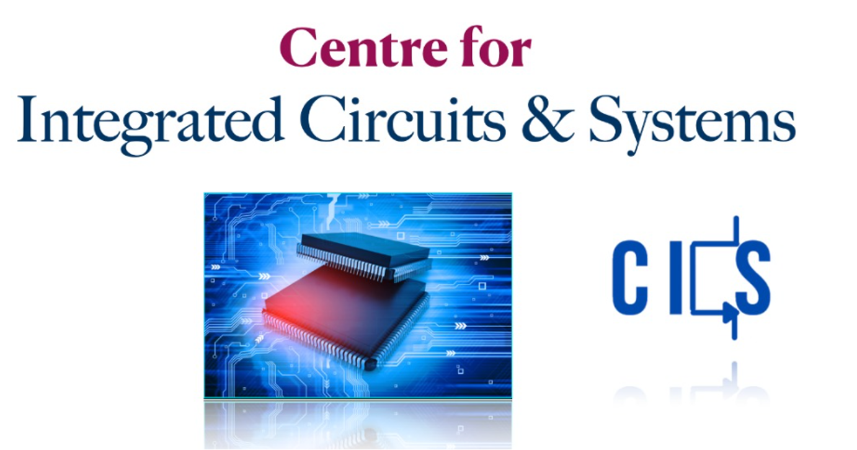

## Fig 1.1: Centre for Integrated Circuits and Systems

The CoE consists of passionate students and faculty members willing to create an ecosystem that inspires the VLSI/Electronics system designer, to nurture the skills and innovative ideas, and to promote sustainable and interdisciplinary research, with inclusive societal concerns. The CoE promotes a coherent training program that enhances the skill set of young designers in the specified areas with academia-industry collaboration in India and abroad. It aims at engaging enthusiastic students in design/development activities through funded projects and consultancy works from various organisations thereby contributing to the growth of the nation. The logo of the proposed organization is shown in Fig. 1.1.

**1.2 Vision**

Creating an ecosystem that inspires the VLSI/Electronics system designer, nurturing their skills and innovative ideas, and promoting sustainable and interdisciplinary research, with inclusive societal concerns. **1.3 Interdisciplinary Research and Innovation**

Interdisciplinary research is a method of study or research that relies on two or more fields to acquire a more well-developed viewpoint or uncover something new. Interdisciplinary research is gaining prominence and is increasingly seen as necessary. Multiple viewpoints on research difficulties frequently result in better solutions. An inter-disciplinary research centre is an institution or organisation that brings together academics and researchers from several disciplines to cooperate on a specific field of study. These centres frequently focus on cross-disciplinary research initiatives, addressing difficult topics and problems by harnessing the unique viewpoints and experience of scholars from several areas. For the implementation of financed studies and industry consultancy, the institution has taken the following strategy in order to simplify and focus research, to promote proficiency in both students and instructors.

1. Identifying Thematic Areas of Research: Carrying out SWOC analysis of the institution and aligning goals in line with Thrust areas of Govt. & Industry is helping identifying need based areas of research. Thrust areas are identified through road maps, govt. policy documents, Vision 2035, UN SDG 2030, funding agency requirements and such others.
2. Aligning with existing infrastructure and identifying new infrastructure needed: The institution has separate PG / Research budget to cater to new equipment’s and seed funding for students and faculty. Many companies and funding agencies have helped in establishing physical infrastructure and state of the art equipment and software are provided over a period of time
3. Assigning Team: Based on the specialization and competency of the faculty, various interdisciplinary teams are formed to undertake need based research, execute projects and consultancy assignments.
4. Developing Modules and providing training: The newer areas of science and technologies need learning through training from experts. Based on the need of the faculty, training in thematic areas are provided through institutional funding and providing seed funding for initial experimentation & Simulation, wherever needed. Mentoring by Industry & Research Experts in the thematic areas are also taken up for better understanding of the need and execution.
5. Executing work as per standards: Funding agencies and industries expect deliverables in terms of products, processes and systems, which are scalable. Efforts are made to execute the projects and consulting work based on the goals set and measured through publishing in peer reviewed journals, developing prototypes and obtaining Patents and copy rights.
6. Reporting periodically & Scale Up the CoE / CoC: Documentation of the work carried out and submitting to the agencies is a continuous assignment and also helps future work to be undertaken. The whole exercise of interdisciplinary research and innovation is also helping in developing incubation centre and Start-ups for commercialization of IPs, and alternate Revenue generation for sustainability.

**1.3.1 Research Collaboration**

The centre is well-equipped with skilled staff, computing infrastructure, and appropriate open source and commercial teaching learning tools. Fig 1.2 depicts the numerous research domains the CICS is actively a part of. It involves research activities, sensors fabrication, sensors integration, design thinking, and research in the field of IoT and IIoT.

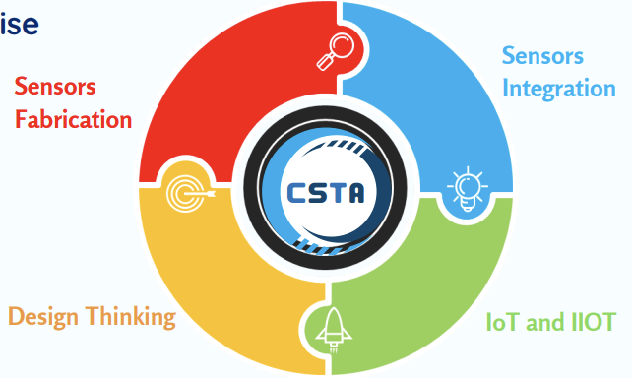

**Fig 1.2:** Research domains

**1.4 Objectives**

1. To create an eco-system for ultra-low power analog, mixed-signal, RF, and power management services and realize their benefits to society in near future.
2. To promote a coherent program of training that will enhancethe skill set of underprivileged people in the specified areas with academia-industry collaboration in India and abroad.
3. To engage in design/development activities by carrying out funded projects and consultancy works for various organisations and thereby partake in the growth of the nation.
4. To establish as a stand-alone centre that can attract people from various domains and leverage substantial interdisciplinary research.

**1.5 Courses in Curriculum**

The circuit branches of Electronics and Communication Engineering, Electrical and Electronics Engineering, Electronics and Instrumentation, and Electronics and Telecommunication have foundation courses in the areas of IC Design in the curriculum, so that any student from the circuit branch can use the facility available in the centre.   
 The Electronics and Communication Department's curriculum includes the center's specialised courses as core and electives. This will give the activities at the centre a boost.

UG Courses

* Analog Microelectronic Circuits
* Analog Integrated Circuit Design
* Radio Frequency and Millimeter Wave IC Design
* Mixed signal IC Design

PG Courses

* Analog Integrated Circuit Design
* Radio Frequency IC Design
* Digital VLSI Design
* VLSI for Testing and Testability

**1.6 Outcomes**

1. Engage in the fabless design of various IP blocks for Analog ICs / Mixed Signal ICs / RFICs / Memory / Digital ICs / SoCs/ASICs.
2. Train students and faculty across India in the areas of Analog ICs / Mixed Signal ICs / RFICs / Memory / Digital ICs / SoCs/ASICs.
3. Engage in R&D projects in the areas of Analog ICs / Mixed Signal ICs / RFICs /Memory / Digital ICs / SoCs/ASICs.

## The chapter highlighted the organization's profile, as well as the research facility supplied to students under the supervision of experienced academics in order to improve students' perspectives on forthcoming newest technologies through inventive and exciting talks at an industry level. The next chapter addresses the department's activities, possible outcomes from the internship, numerous modules and Industry level projects in commercial licensed softwares, as well as the many MoUs formed by COE with the industries for the benefit of students.

**CHAPTER 2**

**ACTIVITIES OF THE DEPARTMENT**

## CHAPTER 2 ACTIVITIES OF THE DEPARTMENT

## In this chapter, the focus is on the various activities conducted by the CICS, and also the research work in respective fields of electronics. The curriculum offered by the CoE has specialised courses of the centre as core and electives. The proposed centre also conducts specialized courses for the engineering branches of EC, ET, EE and EI.

**2.1. Activities of CICS**

The activities under the proposed Centre can be categorised in two groups.

1. Provide industry certified internship for UG/PG students throughout the year for all 3 modules in the areas of IC Design
2. Fundamental module (1st and 2nd semester UG students of all circuits branches)
   1. Intermediate module (3rd and 4th semester UG students of all circuits branches, 1st semester PG students of VLSI/Communication Branch)
   2. Advanced module (5th and 6th semester UG students of all circuits branches, 2nd and 3rd semester PG students of VLSI/Communication Branch)
3. Execute consultancy projects with the companies that we have tied up with. This will help PG/UG students to work on industry related projects which will give them better exposure to the state of the art work.
4. Apart from regular workshops, the centre can float specialised certificate programmes in various areas of IC Design in the following years as it is of huge demand.

The specialised certification programmes can be run in online / offline mode with 3 Core courses and 2 Elective courses, with capstone projects. The curriculum of ECE has the specialised courses of the centre as core and electives. This will bring in momentum to the activities in the centre. The centre is well-equipped with skilled staff, computing infrastructure, and appropriate open source and commercial teaching learning tools. The centre will focus on a handful of activities in future as shown in Fig 2.1.

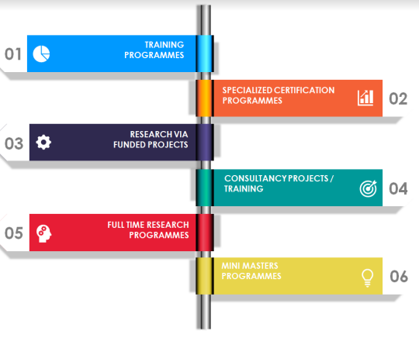

**Fig 2.1.** Activities under the proposed centre

**2.2. Various modules of training programmes**

The proposed centre conducts training programmes for undergraduate as well as post-graduate students. The modules included in the training programme are listed in Table 2.1. It consists of two modules, each containing individual levels.

**Table 2.1:** Training programmes

|  |  |  |
| --- | --- | --- |
| **Module 1: Analog Design** | **Level 1** | Introductory course on Analog IC Design with hands on using simulators |
| **Level 2** | “Op-amps for everyone” with hands on simulators |
| **Level 3** | Design of low power analog modules with bias generation with hands on using simulators |
| **Module 2: Mixed signal Design** | **Level 1** | Introductory course on Mixed signal IC Design with hands on using simulators |
| **Level 2** | “Data converters for everyone” with hands on using simulators |
| **Level 3** | Design of ADC/DAC Architectures from specifications with hands on using simulators |

**2.3. Courses in the curriculum**

The circuit branches of EC, EE, EI and ET have the foundation courses in the areas of IC Design in the curriculum so that any student from circuit branch can make use of the facility available in the centre. The curriculum of ECE has the specialised courses of the centre as core and electives. This will bring in momentum to the activities in the centre. Table 2.2 shows the courses offered to undergraduate and post-graduate students

**Table 2.2:** Courses offered by the CoE

|  |  |
| --- | --- |
| UG Courses | |
| 1 | Analog Microelectronic Circuits (with lab) |
| 2 | Analog Integrated Circuits Design |
| 3 | Mixed Signal IC Design |
| 4 | Radio Frequency & MMW Integrated Circuit Design |
| 5 | VLSI Testing for ICs |
| PG Courses | |
| 1 | Analog Integrated Circuits Design (with lab) |
| 2 | Radio Frequency Integrated Circuit Design |
| 3 | Digital IC Design |
| 4 | VLSI Testing and Testability |

**2.4. Value Addition to the Institution**

The COE brings value addition to the institution.

1. By enhancing research, consultancy works in the proposed themes and domains.
2. By offering training programmes to students of all disciplines from the various modules offered by the centre and can carry out design projects in the centre.
3. Through funded projects from public and private sectors.
4. By promoting PG and full time PhD through research activities.
5. By offering value addition to the degrees offered by the institution through projects, training programs, workshops, symposiums.
6. Fabricated chips will be added to the chip gallery of the centre which can elevate the centre to a hub for IC Design.

**2.5. Benefits to the Research Community**

The centre provides benefits to the research community in the following ways.

1. Students / Faculty, both internal and external, can take up the structured training programmes enhancing the research activities.
2. Research scholars can use the facility of the centre for their research.

**2.6. MoUs from COE**

The centre has signed MOUs with

1. Entuple technologies to assist the centre with fabless design. This will be done by the experts in the appropriate field from Entuple technologies.
2. Lekha Wireless solutions which will offer consultancy projects and internships to the students from RVCE.
3. WPIF which will offer internships to students
4. SCL technologies have offered 180nm PDK.

The chapter discussed the potential outcomes of the internship with industry level projects, the benefits to the research community, and the value added to the institution through a possible publication and innovative projects carried out by students for the welfare of the community, adding a significant status to the institution. The next chapter focuses on the tasks completed during the Internship, followed by the Internship's attained learning outcomes.

## CHAPTER 3 TASKS PERFORMED

## 

## CHAPTER 3 TASKS PERFORMED

## This chapter includes all the tasks performed in the internship and discusses the objectives, design, implementation and results compared with expected outputs. The tasks provided were done under the supervision of the coordinator. The tasks mainly focused on working of analog circuits, and digital circuits built using analog electronic components.

## 3.1 Objectives The objectives covered during the course of the internship are as follows: -

1. To understand the basic rules and laws commonly used in the designing and analysis of circuits, namely Kirchhoff’s voltage law, Kirchhoff’s current law, DeMorgan’s theorem and many more.
2. To understand the behaviour and operation of linear and non-linear electronic components such as resistor, capacitor, inductor, diode, MOSFET, operational amplifiers, etc.
3. To understand the behaviour and operation of digital combinational and sequential logic circuits such as gates, multiplexers, encoders, decoders, latches, etc.
4. To design circuits using the above components and to analyse them using the LTspice software simulating the circuits and analysing their results.

**3.2 Week-wise Tasks Performe****d**

The tasks performed during the course of the internship are listed in detail below. In the first week, the basics of network analysis was covered. In the consecutive weeks, the simulation software LTspice was introduced. Using the software, several analog and digital circuits were designed and their behaviour was analysed. .

## WEEK 1

* Introduction to the field of electronics and its various branches.
* Basics of networks including KCL and KVL were refreshed.
* An introduction to digital electronics was given, where information regarding basics were taught.
* A hands-on interactive session was held to introduce LTSPICE.
* Testing for linearity of various electronic components (Resistor, Capacitor, Inductor) was carried out.
* Quiz conducted regarding the sessions held.
  + 1. **WEEK 2:**
* A webinar on “*INTRODUCTION TO MICRO/NANO-FABRICATION TECHNOLOGY WITH DEVICE EXAMPLES*” was conducted by Ms. Sabhiha Sultana, Prof., IISc, *CeNSE (Centre for Nano science and engineering),* organised by IEEE RVCE, CAS as a part of the internship at CICS.
* Several important microfabrication techniques such as photolithography, soft lithography, bonding, etching and film deposition were talked about.
* A quiz on the webinar had been conducted.
* Sessions on rectifiers, full wave and bridge rectifiers using diodes, were conducted by the faculty. The same were tested and analysed in the LTspice simulation software.
* Sessions on digital electronics were conducted which covered the working of multiplexers, decoders and encoders.
* During the end of the second week, a session on the behaviour and operation of MOSFETs was conducted.
* The concept of channel length modulation was introduced, which was later tested & verified in the LTSpice software, by varying the aspect ratio.
  + 1. **WEEK 3:**
* In the final week, the students were asked to choose a project of their choice and work on it for the entire week.
* The finished project files, along with the simulation and log files, were submitted to the faculty in charge, based on which the completion of the internship was determined.

The circuits that were rigged up in the software, simulated and analysed were shown in Fig 3.1 to 3.8.

Fig. 3.1 depicts an OR gate that is built using p-n junction diodes, and the respective waveforms obtained after simulation of the same is shown in Fig. 3.2.

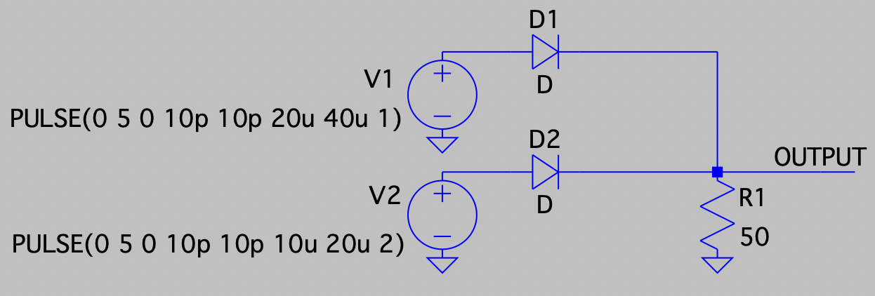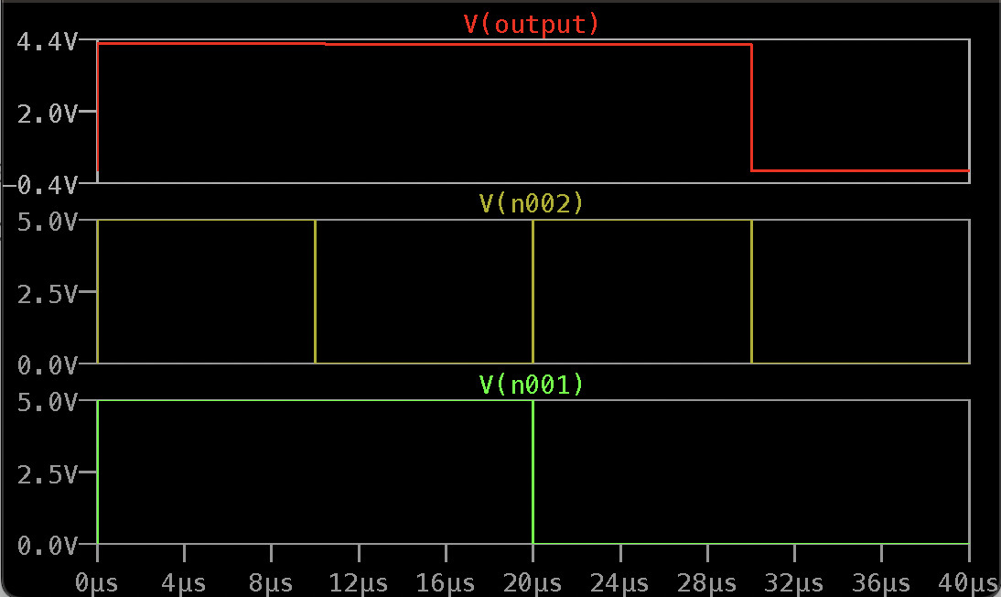

**Fig 3.2:** Simulation result of OR Gate using diodes

**Fig 3.1:** OR Gate using diodes

Fig. 3.3 depicts an AND gate using NOR gates, and the respective waveforms obtained after simulation of the same is shown in Fig. 3.4.

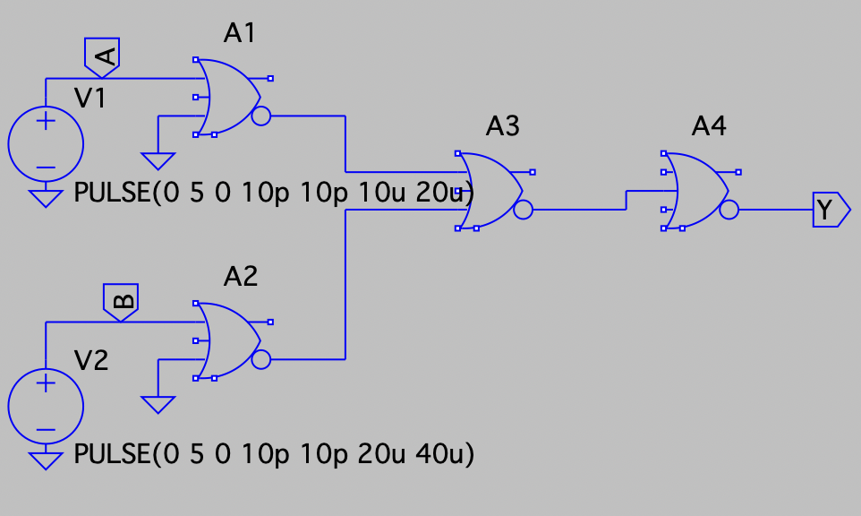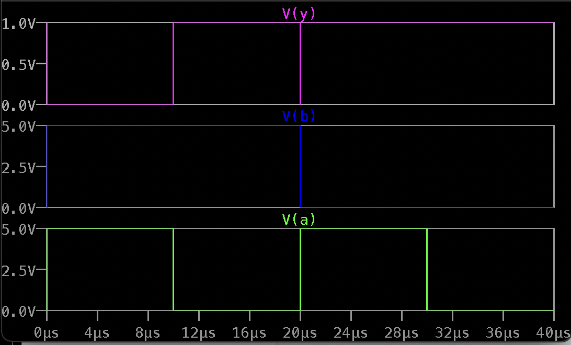

**Fig. 3.4:** Simulation result of circuit in Fig. 3.3

**Fig 3.3:** AND gate using NOR gates

Fig. 3.5 depicts a half adder circuit that is built using only NAND gates, and the waveforms obtained after the simulation of the circuit in Fig. 3.5 is shown in Fig. 3.6.

Fig. 3.7 shows a NAND gate built using MOSFETs using CMOS technology, and the simulation result obtained is shown in Fig. 3.8.

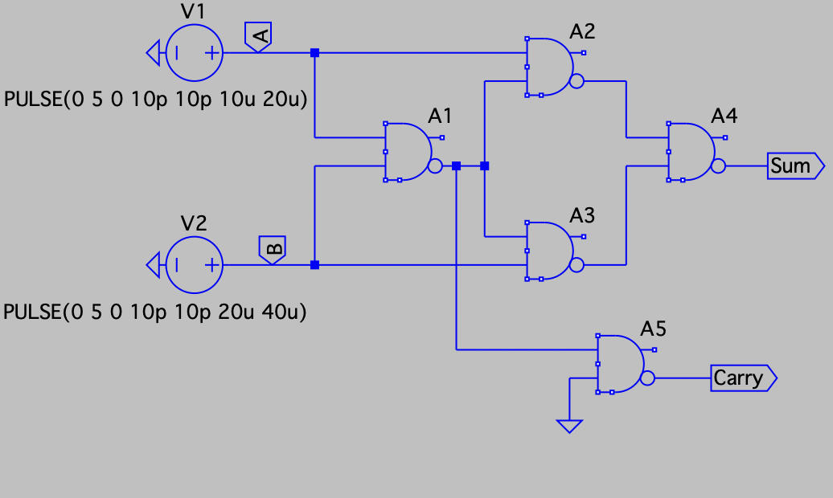

**Fig 3.5:** Half adder using NAND gates

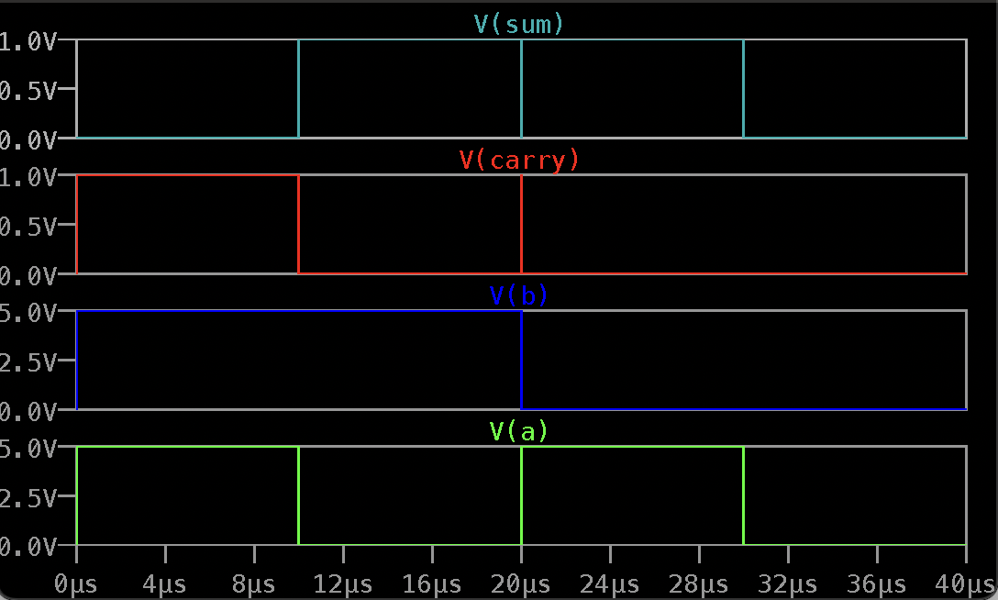

**Fig 3.6:** Simulation result of Half adder using NAND gates

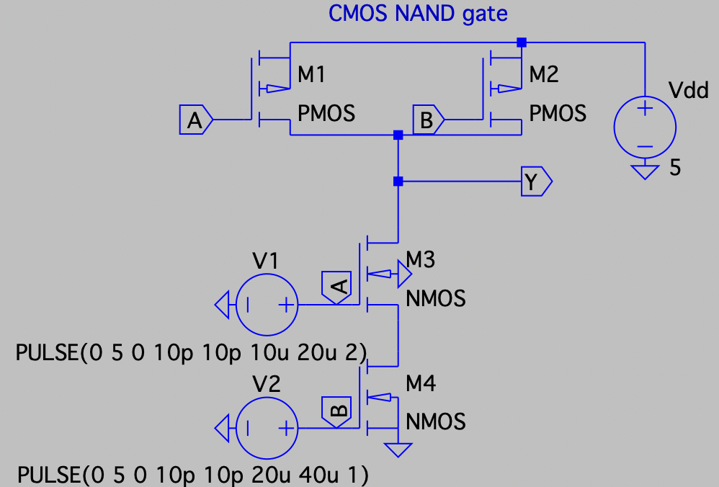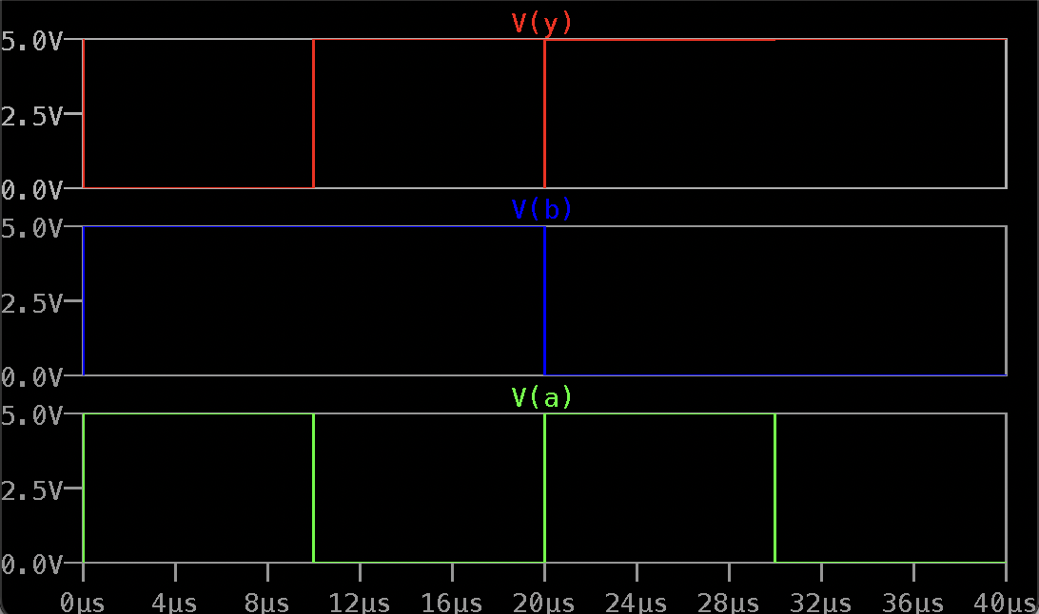

**Fig 3.8:** Simulation result of Half adder using NAND gates

**Fig 3.7:** CMOS NAND Gate

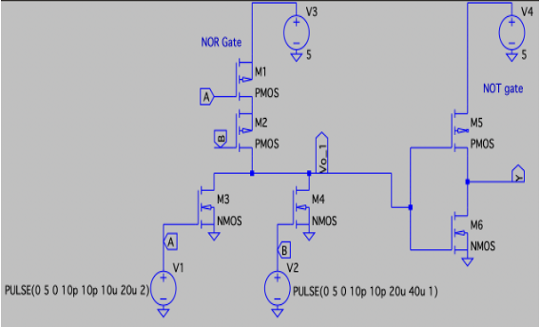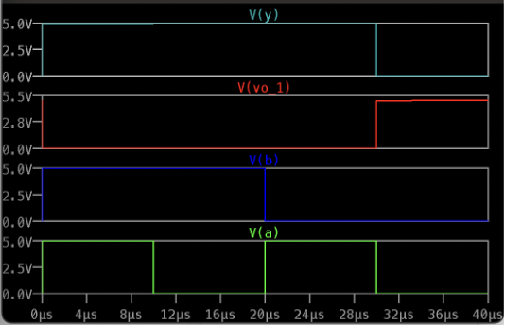OR gate using CMOS OR and NOT gates [7] is shown in Fig. 3.9. The circuit is simulated in LTspice and the obtained resultant waveforms is shown in Fig. 3.10.

**Fig 3.10:** Simulation result of OR gate using   
 CMOS OR and NOT gates

**Fig 3.9:** OR gate using CMOS OR   
 and NOT gates

An inverting amplifier circuit using operational amplifier, shown in Fig. 3.11, was rigged up in LTspice software, and simulated. The simulation results obtained are shown in Fig. 3.12.

**

**Fig 3.12:** Simulation result of Inverting amplifier using Operational Amplifier

**Fig 3.11:** Inverting amplifier using Operational Amplifier

A non-inverting amplifier circuit using operational amplifier, shown in Fig. 3.13, was rigged up in LTspice software, and simulated. The simulation results obtained are shown in Fig. 3.14.

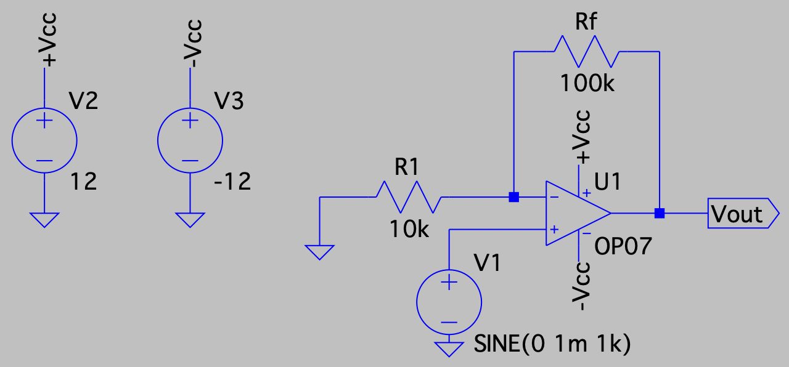

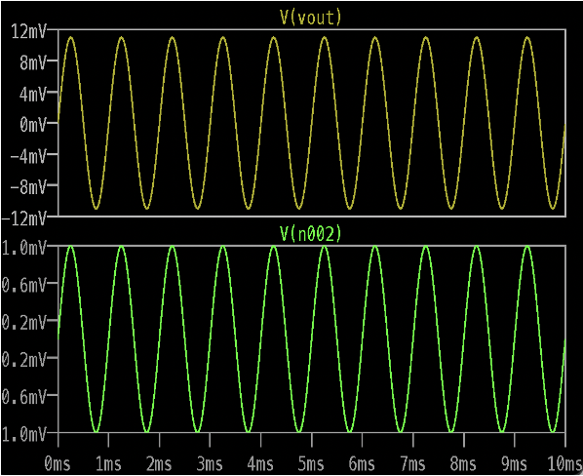

**Fig 3.13:** Non-inverting amplifier using operational amplifier

**Fig 3.14:** Simulation result of Non-inverting amplifier using operational amplifier

**3.3 Project Work Undertaken**

During the course of the internship, during the last week, the proposed project was to build an RC Coupled Amplifier for a Gain of 100 (40dB).

**3.3.1 Introduction**

A transistor type known as a bipolar junction transistor (BJT) employs both electrons and electron holes as charge carriers. A bipolar transistor can be used for switching or amplifying by allowing a little current to be injected at one of its terminals to control a much greater current flowing between the terminals.

A BJT has three regions of operation viz., Saturation, Active and Cut-Off, which can be seen on the output characteristics graph. In the saturation region, the base-emitter junction as well as the collector-base junction of the BJT are forward biased by applying external biasing. In this region of operation, the collector current, $I_{C}$ varies linearly with the applied voltage. In the cut-off region, both the base-emitter junction as well as the collector-base junction of the BJT are reverse biased. As a result, a small current (although negligible) flows in the circuit, which is called leakage current or collector-to-base leakage current. In the active region of operation, the base-emitter junction is forward biased and the collector-base junction is reverse biased. In this configuration, a constant collector current, $I_{C}$, irrespective of the supply voltage, flows in the network.

For a BJT to work as an amplifier, it has to be biased in the active region of its operation. The operating point must be chosen such that it lies in the middle of the active region for faithful amplification[5].

A resistance capacitance coupled amplifier (RCCA) is a multi-stage amplifier circuit that is widely used in electronic circuits. The different stages of the amplifier are linked together using a resistor-capacitor combination, thus the term RC Coupled. Fig. 3.15 shows a single-stage RC Coupled amplifier, in common-emitter configuration. The resistors R1, R2, RC and RE provide the necessary DC bias to the circuit. The capacitors C1 couples the input to the base of the transistor and capacitor C2 couples the output of the first stage to the next stage, as input. Capacitor CE acts as a bypass capacitor, allowing only ac to flow through it and blocking all DC current[6].

In the common-emitter configuration of amplifier, the output is 180° out of phase with the input. Hence, a positive going half-cycle at the input will produce an amplified negative going half cycle at the output.

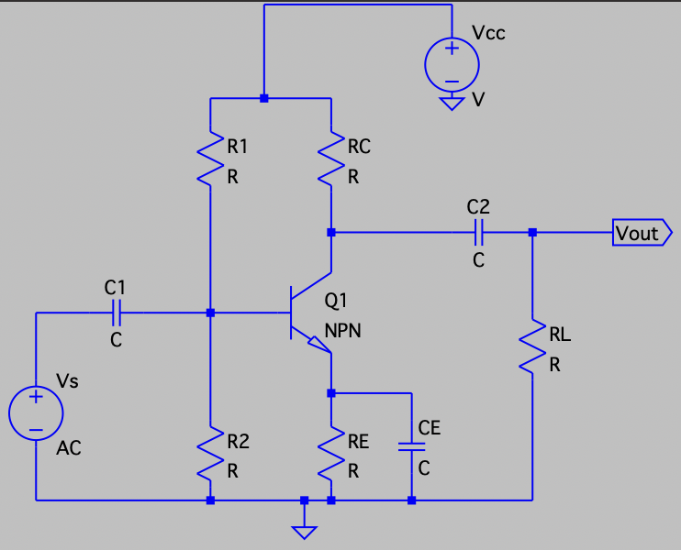

**Fig 3.15:** Single stage RC Coupled amplifier

**3.3.2 Design Process**

The design process involves the following steps­­[2]:-

Step 1: Selection of transistor

* Since the objective is to design the amplifier for a gain of 100, the current gain of the transistor should be around 100.
* The feasible transistors available for the said application in the LTSpice software were BC547B, BC847B, 2N2222.
* Among the choices, BC547B satisfied all the requirements for the specification.

Specifications of the transistor:

$$h_{fe}\left(dc\right)=200{ h}_{fe}\left(ac\right)=220$$

$$h_{ie}=3.2kΩ. V_{CE}=0.25V$$

Step 2: Calculation of $R_{C}$

Gain $A_{v}= -\frac{h_{fe}}{h_{ie}}*R_{C}$ (3.1)

$$-100= \frac{-220}{3200}*R_{C}$$

$$R_{C}\left(std\right)=1.5kΩ \\ Step 3:$$ Selection of Q-Point

$V_{CC}=16V \left(assumed\right)$

$$V_{CE-Q}= \frac{V_{CC}}{2}$$

$$V_{CE-Q}= \frac{16}{2}=8V$$

$$V_{RE}=10\% of V_{CC}$$

$$V_{RE}=1.6V$$

$Current I_{c}= \frac{V_{CC}- V_{CE-Q}- V_{RE}}{R_{C}}$ (3.2)

The equation 3.2 is obtained by applying the Kirchhoff’s voltage law to the collector side. After substituting the respective values into the equation, the collector current is obtained as,

$$∴ I_{C}=4.267mA$$

$$Q-Point is Q\left(8V, 4.267mA\right)$$

Step 4: Calculation of $R_{E}$

$$V_{RE}= I_{C}*R_{E}$$

$$⇒R_{E}= \frac{1.6V}{4.267mA}=374.9Ω$$

$$R_{E}\left(std\right)=350Ω$$

Step 5: Calculation of values of voltage divider resistors, $R_{1}$& $R_{2}$

Stability factor, $s=8 \left(assumed\right)$

$s=1+ \frac{R_{Th}}{R_{E}}$ (3.3)

The stability factor of the circuit is given by equation 3.3. From equation 3.3, the value of Thevenin’s equivalent of $R_{1}$ and $R_{2}$ is obtained.

$$⇒8=1+ \frac{R_{Th}}{350}$$

$$⇒R_{Th}=2.45kΩ$$

$$V_{Th}= V_{BE}+ V_{RE}$$

$$⇒ V_{Th}=0.7+1.6$$

$$∴ V_{Th}=2.3V$$

$$R_{Th}= \frac{V_{Th}}{V_{CC}}*R_{1}$$

$$⇒2450=\frac{2.3}{16}* R_{1}$$

$$∴ R_{1}=17kΩ$$

$Also, { R}_{Th}= \frac{R_{1}{*R}_{2}}{R_{1}+ R_{2}}$ (3.4)

$$∴ R_{2}=2.86kΩ$$

Equation 3.4 gives the definition of Thevenin’s equivalent of $R_{1}$ and $R_{2}$

Step 6: Calculation of values of Capacitors $C_{1}$& $C_{2}$

$$Lower cut-off frequncy, { f}_{L}=20Hz \left(assumed\right)$$

$C_{1}= \frac{1}{2πf_{L}R_{eq}}$ (3.5)

$$R_{eq}= R_{Th} \left| \right| h_{ie}$$

$⇒R_{eq}=2.45kΩ \left| \right| 3.2kΩ$

$$⇒ R_{eq}=1.387kΩ$$

$$∴ C_{1}= \frac{1}{2*π*20*1387}$$

$$⇒ C_{1}=5.737μF$$

$$C_{2}= \frac{1}{2πf_{L}R_{C}}$$

$$⇒ C_{2}=\frac{1}{2*π*20*1500}$$

$$⇒ C_{2}=5.35μF$$

$$C_{E}= \frac{1}{2πf_{L}R_{E}^{'}}$$

$$R_{E}^{'}=\left(\frac{R_{Th} \left| \right| h_{ie}}{h_{fe}+1}\right) \left| \right|{ R}_{E}$$

$${⇒R}_{E }^{'}=\left(\frac{2.45kΩ \left| \right| 3.2kΩ}{220+1}\right)\left| \right|350Ω$$

$${⇒R}_{E}^{'}=6.168Ω$$

$$∴ C_{E}= \frac{1}{2*π*20*6.168}$$

$$⇒C_{E}=1.2mF$$

Equation 3.5 is the general formula for calculating the value of the capacitor for the know values of the lower cut-off frequency and the equivalent resistance as seen from the terminals of the capacitor under consideration.

Step 7: Calculation of Bandwidth

$$Lower cut-off frequency, f_{L}=20Hz \left(assumed\right)$$

$$Lower cut-off frequency, f_{L}=18.8Hz \left(simulation result\right)$$

$$Higher cut-off frequency, f_{H}=117Mhz \left(simulation result\right)$$

$∴Bandwidth, BW= f_{H}- f_{L}$ (3.6)

$$BW=117MHz-18.8Hz$$

$$⇒Bandwidth ≅117MHz$$

With the obtained values of the components, the gain that was obtained after simulating the circuit was slightly higher than 100 (40dB). Hence, the values of the voltage divider resistors, $R_{1}$ and $R_{2}$ were adjusted to get the gain to be 100 (40dB).

The final circuit that was designed and simulated is shown in Fig. 3.9. The simulated result contains the input versus the output waveforms, shown in Fig 3.10, and the frequency response of the circuit shown in Fig. 3.11. From the figures, it is evident that the objective given was successfully met, and the theoretical results were also verified[5].

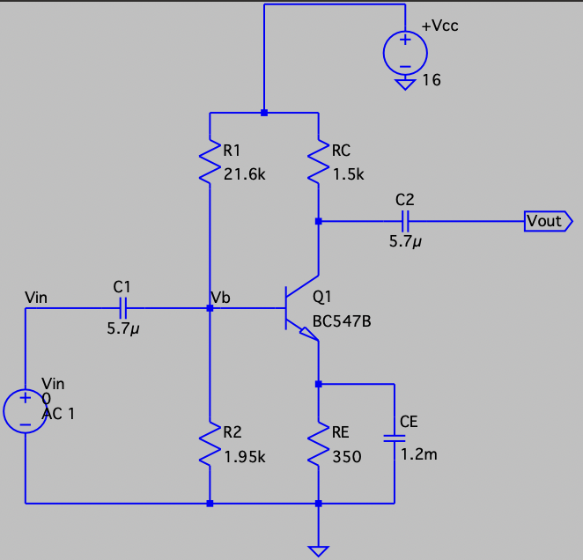

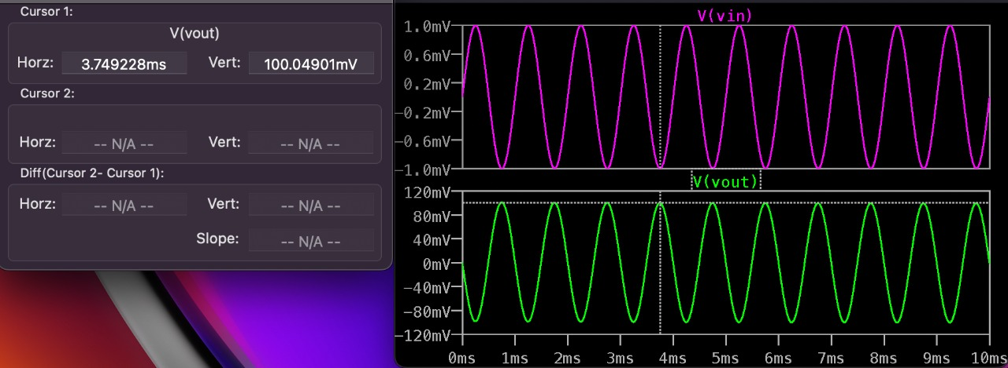**Fig 3.16:** The final designed RC Coupled amplifier circuit

**Fig 3.17:** Input v/s Output waveforms

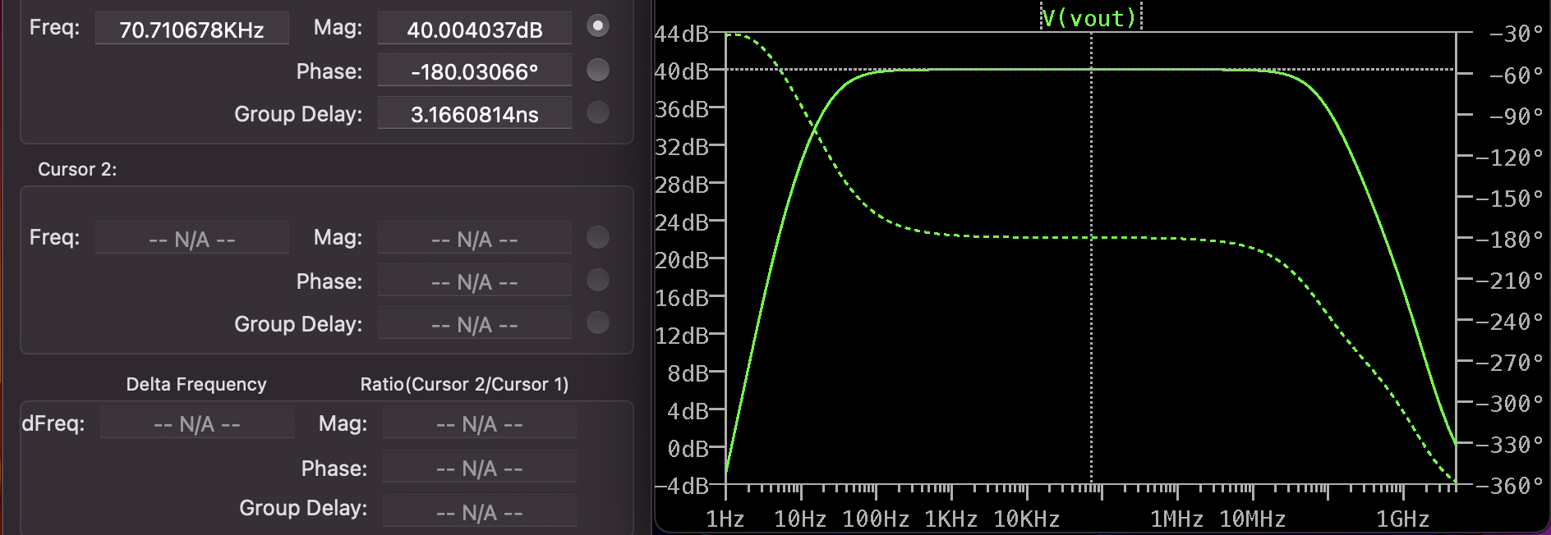

**Fig 3.18:** Frequency response curve of the designed RC coupled amplifier

**3.3.3 Challenges faced during the project**

* Could not find the exact transistor model that was required, available in the LTspice software. Hence, the transistor BC547B was chosen.
* Adjusting the gain precisely to 100 (40dB) by varying the value of the transistors.
* The values of components obtained were not satisfying the objective requirements. So, the calculations had to be done once again.

This chapter focused on the tasks that were performed during the course of the 3 week internship, and also a detailed explanation regarding the project that was carried out during the period of the internship.

The next chapter will be dedicated to the skills acquired during the course of the internship and also the reflections and lessons learnt, during the 3 week internship.

**CHAPTER 4**

**REFLECTIONS**

**CHAPTER 4  
REFLECTIONS**

The internship was carried out for 6 weeks. The internship provided a platform for a thorough revision of concepts which are quintessential at and industry level. This chapter first provides the results and draws conclusions of the project that was undertaken during the internship program. It further encapsulates the learning outcomes of the internship.

**4.1 Results**

RC coupled CE amplifier was designed and its operation was verified. The circuit was simulated using LTspice software and theoretical values were verified. The obtained value of gain and bandwidth after simulation was equal to 100 i.e., 40dB, and 117MHz respectively.

**4.2 Conclusions**

The inference of the project undertaken during the internship program was that when designing analog circuits and systems, several variables have to be taken into consideration. In the case of RC coupled amplifier, There is a trade-off between gain, bandwidth and the operating point of the transistor used. Keeping all of this in mind, an optimal solution/design has to be developed which is fast as well as efficient in its operation. The following parameters were obtained after the design and testing of the proposed project.

**Table 4.1:** Values obtained after simulation of RC Coupled Amplifier

|  |  |  |
| --- | --- | --- |
| **Circuit** | **Gain** | **Bandwidth** |
| RC Coupled amplifier using BJT in CE configuration | 100.07 | 117MHz |

**4.3 Learning Outcomes**

* Design and implementation of various analog and digital circuits in LTspice: Implementation of the most basic circuits in LTspice, and building more complex systems by utilizing the basic circuits
* Fabrication of MOSFETs: The various techniques involved in the different steps of MOSFET fabrication, the existing technology and future scope of improvements in terms of reduction in size and subsequent increase in performance.
* Implementation of various combinational digital circuits such as MUX, DEMUX, encoder, decoder, adders, subtractors: These basic circuits form the basis of all the complex circuits that can be built, and are an integral part in the design of any digital circuit.
* Implementation of various sequential digital circuits: Flip-flops and latches are used extensively as memory units or registers. They are used to implement counters, shift registers, analog to digital converters, digital to analog converters, clocks, etc.
* Optimization techniques: Various techniques such as pseudo NMOS logic, pass transistor logic, and transmission gate logic which are used to optimize parameters such as power consumed, area occupied, cost, etc.
* Verilog programming: Three types of modelling - behavioral modelling, dataflow modelling, structural modelling, and implementation of basic circuits.

REFERENCES

1. LTspice – AN Introduction, Jan Hvolgaard Mikkelsen, 2005, Aalborg Uni., Denmark
2. M. N. Ibrahim, Z. H. C. Soh, I. H. Hamzah, and A. Othman, ‘A SIMULATION OF SINGLE STAGE BJT AMPLIFIER USING LTSPICE’, 2016.
3. F. Asadi, “Simulation of Electronic Circuits with LTspice®,” *Essential Circuit Analysis using LTspice®*, pp. 177–364, 2022.
4. D. G. C. Luck, “A Simplified General Method for Resistance-Capacity Coupled Amplifier Design”, in *Proceedings of the Institute of Radio Engineers*, vol. 20, no. 8, pp. 1401-1406, 2012.
5. J. Millman and C. C. Halkias, Electronic Devices and circuits. New Delhi: *Tata Mcgraw Hill Higher Education*, 2007.
6. R. L. Boylestad and L. Nashelsky, “Electronic Devices and Circuit Theory”. New Delhi: *Pearson Education*, 2014.
7. A. S. Sedra, K. C. Smith, T. C. Carusone, and V. Gaudet, Microelectronic circuits. New York: Oxford University Press, 2021.
8. J. W. Bandler, R. M. Biernacki, Q. Cai and S. H. Chen, "Compression analysis of a high power BJT amplifier," *Third International Workshop on Integrated Nonlinear Microwave and Millimeterwave Circuits, Duisburg, Germany, 1994*, pp. 173-178, doi: 10.1109/INMMC.1994.512525.
9. P. Ptak, “APPLICATION OF THE SOFTWARE PACKAGE LTSPICE FOR DESIGNING AND ANALYSING THE OPERATION OF ELECTRONIC SYSTEMS,” SOCIETY. INTEGRATION. EDUCATION”, *Proceedings of the International Scientific Conference*, vol. 5, pp. 402–409, May 2018, doi: 10.17770/sie2018vol1.3118.
10. K. Biswal, S. K. Kar, M. C. Tripathy and S. Swain, "Modelling and Stability Analysis of a Fractional-Order RC Coupled BJT Amplifier," *2022 2nd Odisha International Conference on Electrical Power Engineering, Communication and Computing Technology (ODICON)*, Bhubaneswar, India, 2022, pp. 1-5, doi: 10.1109/ODICON54453.2022.10009975.